DGX SPARK workload---ComfyUI
ComfyUI是AI工作站的典型应用场景，以可视化的方式集成文生图、文生视频、AI Agent等多种应用。

1、ComfyUI工作流---文生图
模型选择：v1-5-pruned-emaonly-fp16.safetensors（Unet，占用显存约2GB）
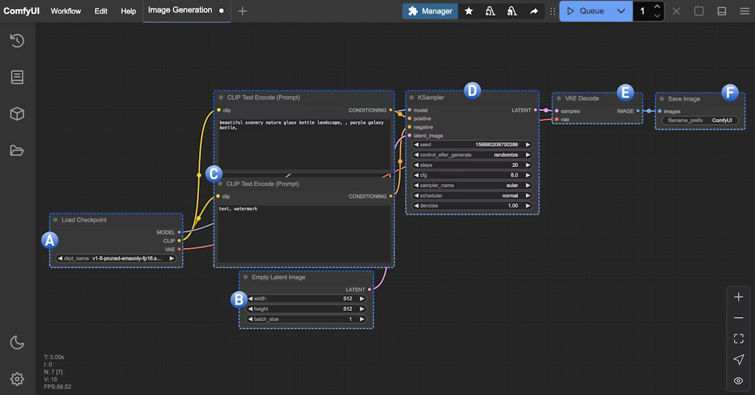

1.1 节点说明
Load Checkpoint node
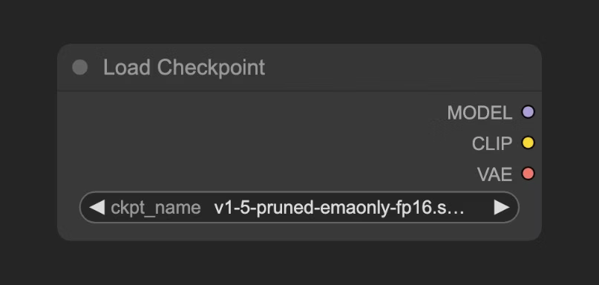
此节点通常用于加载图像生成模型。检查点通常包含三个组件：模型（UNet）、CLIP 和 VAE。
模型（U 型网络）：在扩散过程中负责噪声预测和图像生成的 U 型网络模型
CLIP：将我们的文本提示转换为模型能够理解的向量的文本编码器，因为模型无法直接理解文本提示
VAE：在像素空间和潜在空间之间转换图像的变分自编码器，因为扩散模型在潜在空间中工作，而我们的图像是在像素空间中的

Empty Latent Image Node
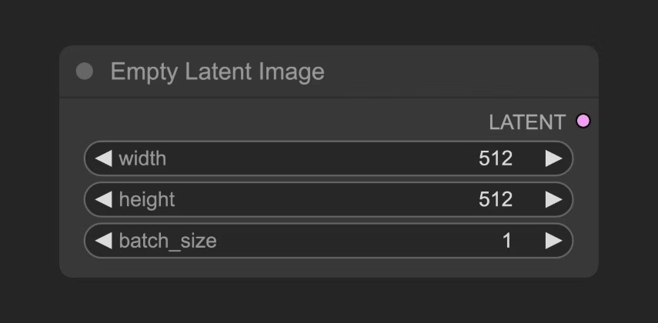
定义一个输出到 KSampler 节点的潜在空间。空白潜在图像节点构建一个纯噪声潜在空间。可以将其功能视为定义画布大小，这决定了我们最终生成图像的尺寸。

CLIP Text Encoder Node
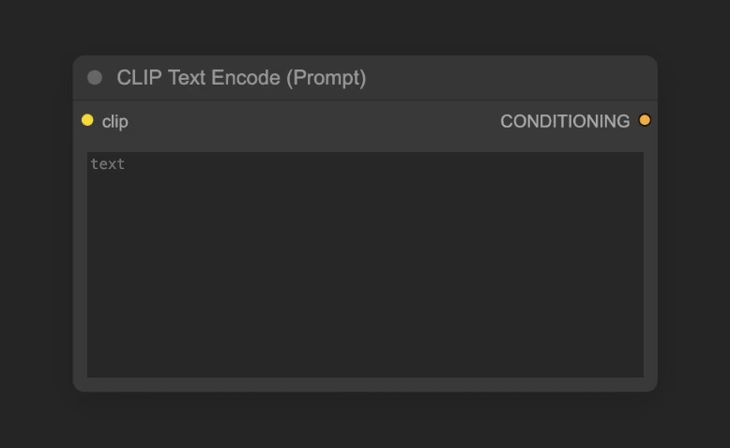
用于编码提示，即您对图像的要求
连接到 KSampler 节点的“正向条件”输入代表正向提示（您希望在图像中出现的元素）。
连接到 KSampler 节点的“负向条件”输入代表负向提示（您不希望在图像中出现的元素）。
提示信息由“加载检查点”节点中的 CLIP 组件编码为语义向量，并作为条件输出到 KSampler 节点。

KSampler Node
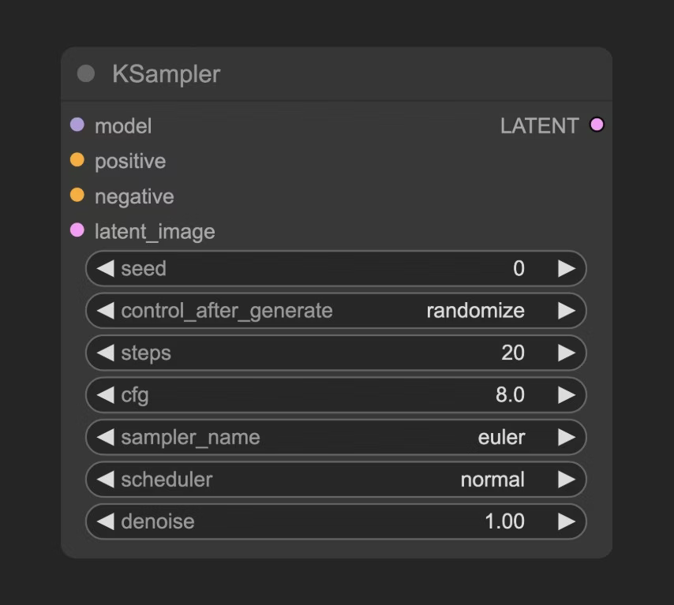
KSampler 是整个工作流程的核心部分，整个噪声去噪过程就在此处进行，最终会生成一个潜在空间图像。
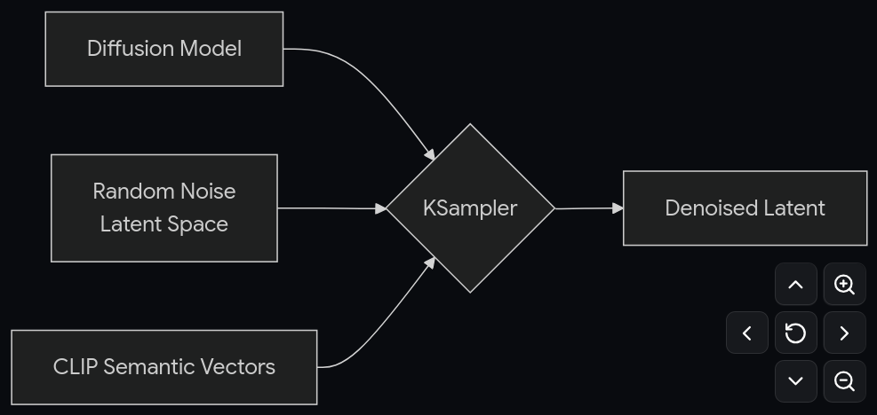
KSampler 节点中，潜空间将种子用作初始化参数来构建随机噪声，并将语义向量“正”和“负”作为条件输入到扩散模型中。然后，根据“步骤”参数指定的去噪步骤数量进行去噪操作。每个去噪步骤都使用由“去噪”参数指定的去噪强度系数对潜空间进行去噪，并生成一个新的潜空间图像。

VAE Decode Node
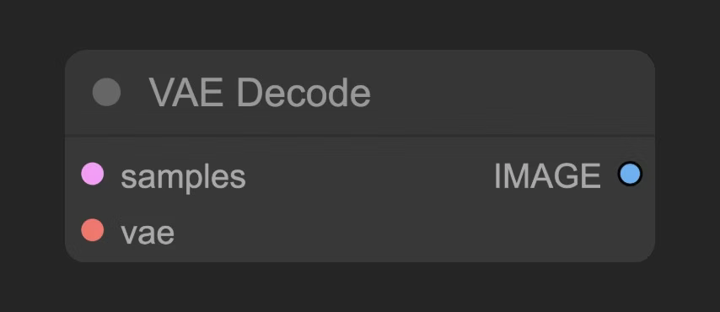
将 KSampler 输出的潜在空间图像转换为像素空间图像

Save Image Node
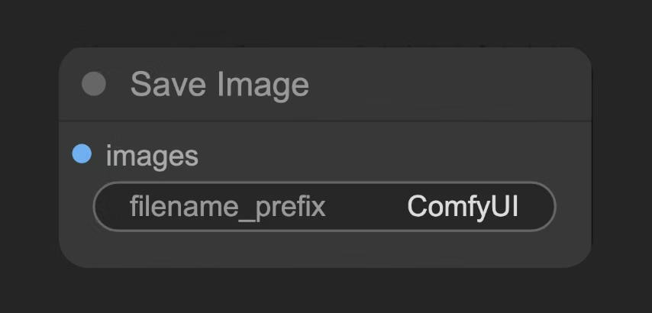
将从潜在空间解码得到的图像预览并保存到本地 ComfyUI/输出文件夹中
工作流.json格式如下：
{"id":"2ba0b800-2f13-4f21-b8d6-c6cdb0152cae","revision":0,"last_node_id":16,"last_link_id":9,"nodes":[{"id":4,"type":"CheckpointLoaderSimple","pos":[60,200],"size":[315,98],"flags":{},"order":0,"mode":0,"inputs":[{"localized_name":"Checkpoint名称","name":"ckpt_name","type":"COMBO","widget":{"name":"ckpt_name"},"link":null}],"outputs":[{"localized_name":"模型","name":"MODEL","type":"MODEL","slot_index":0,"links":[1]},{"localized_name":"CLIP","name":"CLIP","type":"CLIP","slot_index":1,"links":[3,5]},{"localized_name":"VAE","name":"VAE","type":"VAE","slot_index":2,"links":[8]}],"properties":{"Node name for S&R":"CheckpointLoaderSimple","cnr_id":"comfy-core","ver":"0.3.65","models":[{"name":"v1-5-pruned-emaonly-fp16.safetensors","url":"https://huggingface.co/Comfy-Org/stable-diffusion-v1-5-archive/resolve/main/v1-5-pruned-emaonly-fp16.safetensors?download=true","directory":"checkpoints"}]},"widgets_values":["v1-5-pruned-emaonly-fp16.safetensors"]},{"id":3,"type":"KSampler","pos":[870,170],"size":[315,474],"flags":{},"order":8,"mode":0,"inputs":[{"localized_name":"模型","name":"model","type":"MODEL","link":1},{"localized_name":"正面条件","name":"positive","type":"CONDITIONING","link":4},{"localized_name":"负面条件","name":"negative","type":"CONDITIONING","link":6},{"localized_name":"Latent图像","name":"latent_image","type":"LATENT","link":2},{"localized_name":"种子","name":"seed","type":"INT","widget":{"name":"seed"},"link":null},{"localized_name":"步数","name":"steps","type":"INT","widget":{"name":"steps"},"link":null},{"localized_name":"cfg","name":"cfg","type":"FLOAT","widget":{"name":"cfg"},"link":null},{"localized_name":"采样器名称","name":"sampler_name","type":"COMBO","widget":{"name":"sampler_name"},"link":null},{"localized_name":"调度器","name":"scheduler","type":"COMBO","widget":{"name":"scheduler"},"link":null},{"localized_name":"降噪","name":"denoise","type":"FLOAT","widget":{"name":"denoise"},"link":null}],"outputs":[{"localized_name":"Latent","name":"LATENT","type":"LATENT","slot_index":0,"links":[7]}],"properties":{"Node name for S&R":"KSampler","cnr_id":"comfy-core","ver":"0.3.65"},"widgets_values":[685468484323813,"randomize",20,8,"euler","normal",1]},{"id":8,"type":"VAEDecode","pos":[975,700],"size":[210,46],"flags":{},"order":9,"mode":0,"inputs":[{"localized_name":"Latent","name":"samples","type":"LATENT","link":7},{"localized_name":"vae","name":"vae","type":"VAE","link":8}],"outputs":[{"localized_name":"图像","name":"IMAGE","type":"IMAGE","slot_index":0,"links":[9]}],"properties":{"Node name for S&R":"VAEDecode","cnr_id":"comfy-core","ver":"0.3.65"},"widgets_values":[]},{"id":9,"type":"SaveImage","pos":[1220,170],"size":[470,560],"flags":{},"order":10,"mode":0,"inputs":[{"localized_name":"图片","name":"images","type":"IMAGE","link":9},{"localized_name":"文件名前缀","name":"filename_prefix","type":"STRING","widget":{"name":"filename_prefix"},"link":null}],"outputs":[],"properties":{"cnr_id":"comfy-core","ver":"0.3.65"},"widgets_values":["SD1.5"]},{"id":7,"type":"CLIPTextEncode","pos":[410,410],"size":[425.27801513671875,180.6060791015625],"flags":{},"order":7,"mode":0,"inputs":[{"localized_name":"clip","name":"clip","type":"CLIP","link":5},{"localized_name":"文本","name":"text","type":"STRING","widget":{"name":"text"},"link":null}],"outputs":[{"localized_name":"条件","name":"CONDITIONING","type":"CONDITIONING","slot_index":0,"links":[6]}],"properties":{"Node name for S&R":"CLIPTextEncode","cnr_id":"comfy-core","ver":"0.3.65"},"widgets_values":["text, watermark"],"color":"#223","bgcolor":"#335"},{"id":6,"type":"CLIPTextEncode","pos":[411.21649169921875,203.68695068359375],"size":[422.84503173828125,164.31304931640625],"flags":{},"order":6,"mode":0,"inputs":[{"localized_name":"clip","name":"clip","type":"CLIP","link":3},{"localized_name":"文本","name":"text","type":"STRING","widget":{"name":"text"},"link":null}],"outputs":[{"localized_name":"条件","name":"CONDITIONING","type":"CONDITIONING","slot_index":0,"links":[4]}],"properties":{"Node name for S&R":"CLIPTextEncode","cnr_id":"comfy-core","ver":"0.3.65"},"widgets_values":["beautiful scenery nature glass bottle landscape, purple galaxy bottle,"],"color":"#232","bgcolor":"#353"},{"id":15,"type":"MarkdownNote","pos":[400,-70],"size":[440,200],"flags":{},"order":1,"mode":0,"inputs":[],"outputs":[],"title":"Note: Prompt","properties":{},"widgets_values":["Prompts usually have two types:\n\n* Positive Prompt: Tells the model what you want to see.\n* Negative Prompt: Tells the model what you don’t want to see.\n\nThink of it as:<br/>\n👉 Positive = “Do this” <br/>\n👉 Negative = “Don’t do this”\n\n\nDifferent models may interpret prompts differently.<br/>\nSome prefer short, simple phrases; others respond well to detailed descriptions or styles.\nExperiment to see how each model reacts.\n\nAbout SD1.5:<br/>\nStable Diffusion 1.5 is one of the most popular base models.\nIt works best with short, clear prompts and simple concepts, and it has a natural, realistic visual style.\n"],"color":"#432","bgcolor":"#000"},{"id":14,"type":"MarkdownNote","pos":[1220,780],"size":[470,130],"flags":{},"order":2,"mode":0,"inputs":[],"outputs":[],"title":"Note: Output","properties":{},"widgets_values":["Image will auto-save to the ComfyUI/output folder. You can also right-click on the Save Image node and then use the menu to save the image locally."],"color":"#432","bgcolor":"#000"},{"id":13,"type":"MarkdownNote","pos":[510,860],"size":[330,150],"flags":{},"order":3,"mode":0,"inputs":[],"outputs":[],"title":"Note: Image size","properties":{},"widgets_values":["Different models are trained based on datasets of different image sizes. This workflow is using Stable Diffusion 1.5, which is trained based on 512x512 datasets. So, it doesn't perform well on large image sizes."],"color":"#432","bgcolor":"#000"},{"id":5,"type":"EmptyLatentImage","pos":[520,690],"size":[315,106],"flags":{},"order":5,"mode":0,"inputs":[{"localized_name":"宽度","name":"width","type":"INT","widget":{"name":"width"},"link":null},{"localized_name":"高度","name":"height","type":"INT","widget":{"name":"height"},"link":null},{"localized_name":"批量大小","name":"batch_size","type":"INT","widget":{"name":"batch_size"},"link":null}],"outputs":[{"localized_name":"Latent","name":"LATENT","type":"LATENT","slot_index":0,"links":[2]}],"properties":{"Node name for S&R":"EmptyLatentImage","cnr_id":"comfy-core","ver":"0.3.65"},"widgets_values":[512,512,1]},{"id":11,"type":"MarkdownNote","pos":[-374.64204795904664,157.67897602047668],"size":[400,300],"flags":{},"order":4,"mode":0,"inputs":[],"outputs":[],"title":"Note: Model link","properties":{},"widgets_values":["Tutorial\n\n\n## Model link\n\ncheckpoints\n\n- v1-5-pruned-emaonly-fp16.safetensors\n\n\nModel Storage Location\n\n\n📂 ComfyUI/\n├── 📂 models/\n│ └── 📂 checkpoints/\n│ └── v1-5-pruned-emaonly-fp16.safetensors\n\n\n\n## Report issue\nIf you have any problems running this workflow, please report template-related issues via this link: report the template issue here"],"color":"#432","bgcolor":"#000"}],"links":[[1,4,0,3,0,"MODEL"],[2,5,0,3,3,"LATENT"],[3,4,1,6,0,"CLIP"],[4,6,0,3,1,"CONDITIONING"],[5,4,1,7,0,"CLIP"],[6,7,0,3,2,"CONDITIONING"],[7,3,0,8,0,"LATENT"],[8,4,2,8,1,"VAE"],[9,8,0,9,0,"IMAGE"]],"groups":[{"id":1,"title":"Step 1 - Load model","bounding":[50,130,335,181.60000610351562],"color":"#3f789e","font_size":24,"flags":{}},{"id":2,"title":"Step 3 - Image size","bounding":[510,620,335,189.60000610351562],"color":"#3f789e","font_size":24,"flags":{}},{"id":3,"title":"Step 2 - Prompt","bounding":[400,130,445.27801513671875,467.2060852050781],"color":"#3f789e","font_size":24,"flags":{}}],"config":{},"extra":{"ds":{"scale":0.8616886415842859,"offset":[674.4982319454566,398.03581510758676]},"frontendVersion":"1.31.1","VHS_latentpreview":false,"VHS_latentpreviewrate":0,"VHS_MetadataImage":true,"VHS_KeepIntermediate":true,"workflowRendererVersion":"LG"},"version":0.4}

1.2 性能观测

1.2.1 工作流观测
工作流结果：
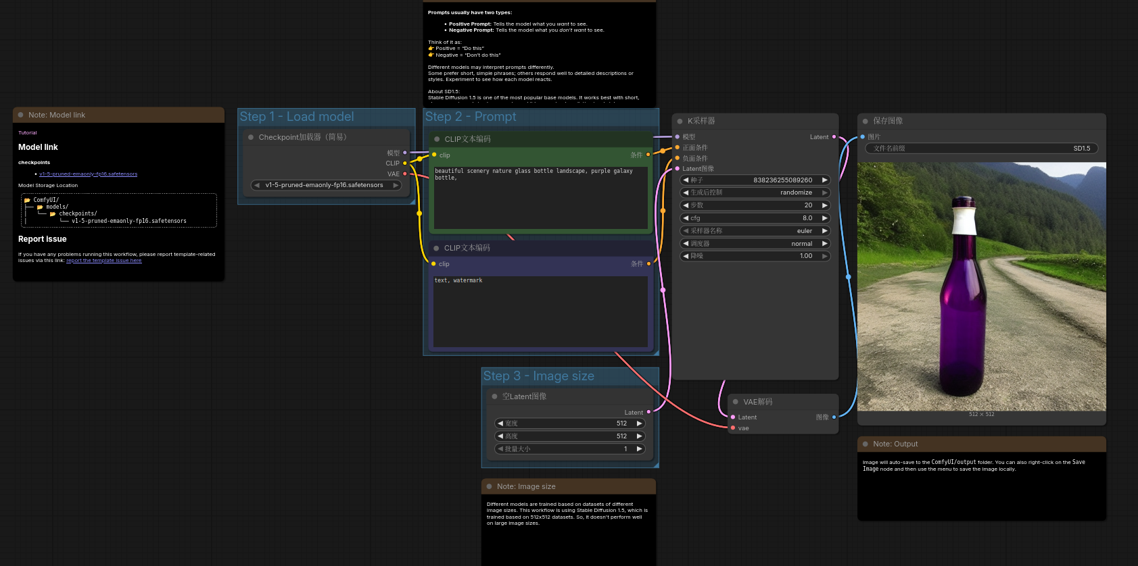

基于工作流节点，添加NVTX观测点，使用Nsight Systems工具观测性能。
关键node：
CheckpointLoaderSimple
CLIPTextEncode
EmptyLatentImage
KSampler
VAEDecode
SaveImage

1.2.2 参数设置
输入：batchsize = 1，图像分辨率512*512。
model：v1-5-pruned-emaonly-fp16.safetensors（Unet，占用显存约2GB）
Positive promt：
（1）beautiful scenery nature glass bottle landscape, purple galaxy bottle,
（2）A bustling city street at night, illuminated by neon lights, with people walking, cars driving, and towering skyscrapers in the background.
（3）A photo of a cute, soft white kitten with its paw around a bottle of Coca Cola. The kitten is in a store with a wooden shelf and a window. The background has a green wall and a few items on the shelf.
（4）A panoramic view of a modern city skyline at sunset, with tall skyscrapers, a wide river, and a vibrant sky with hues of orange and pink.
（5）masterpiece, best quality, good quality, very aesthetic, absurdres, newest, depth of field, focused subject, close up, stylized, in gold and neon shades, wabi sabi, 1 girl, looking at viewer, dynamic angle, from below, from side, relaxing.
Negtive promt:text, watermark

K采样设置：
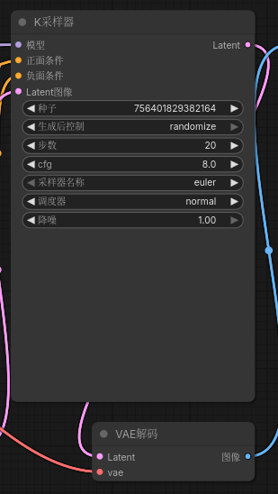
首张图像生成平均耗时：3.8s
后续单张图像生成平均耗时：1.85s
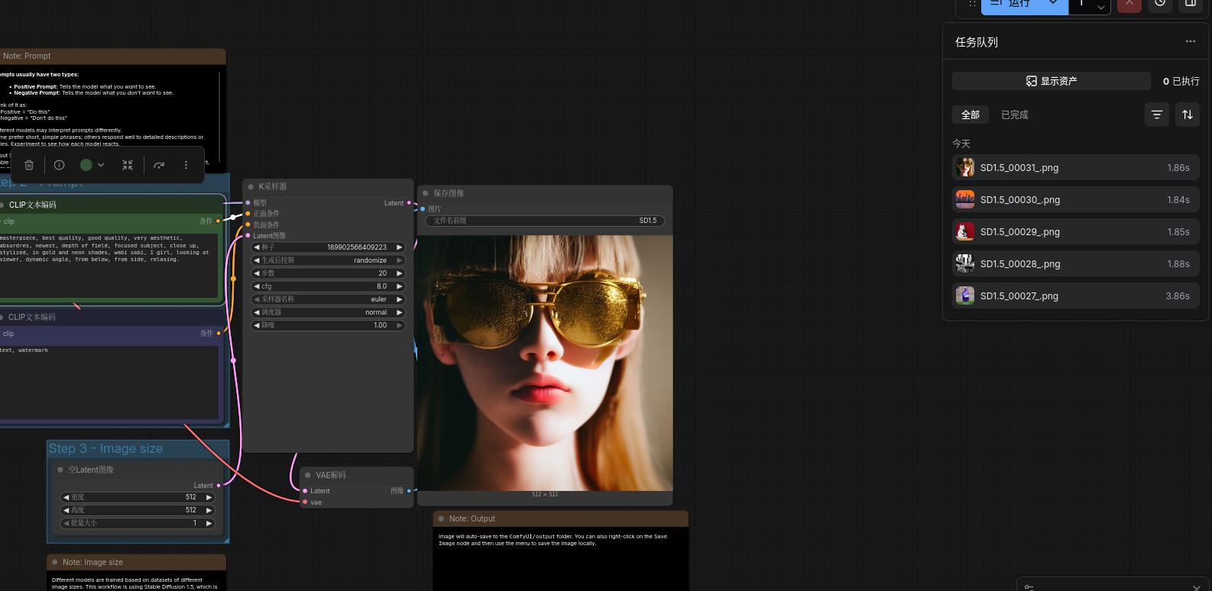

1.2.3 Nsys Analysis Summary
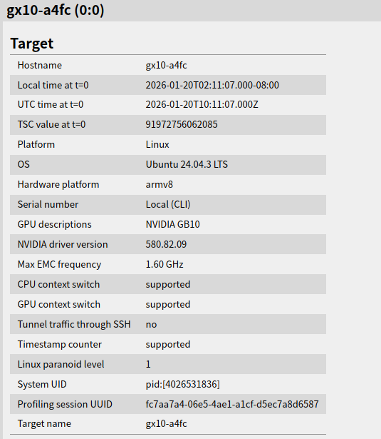
CPU峰值利用率100%
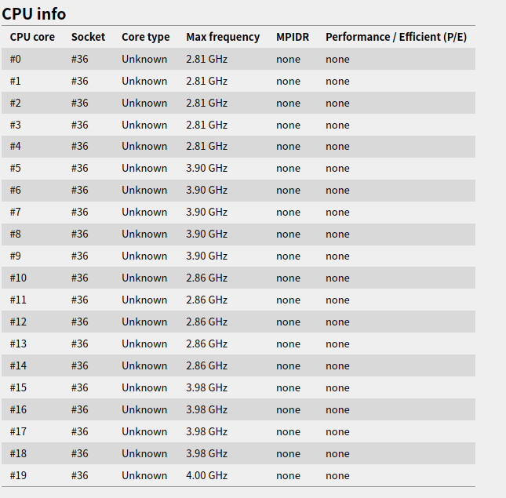

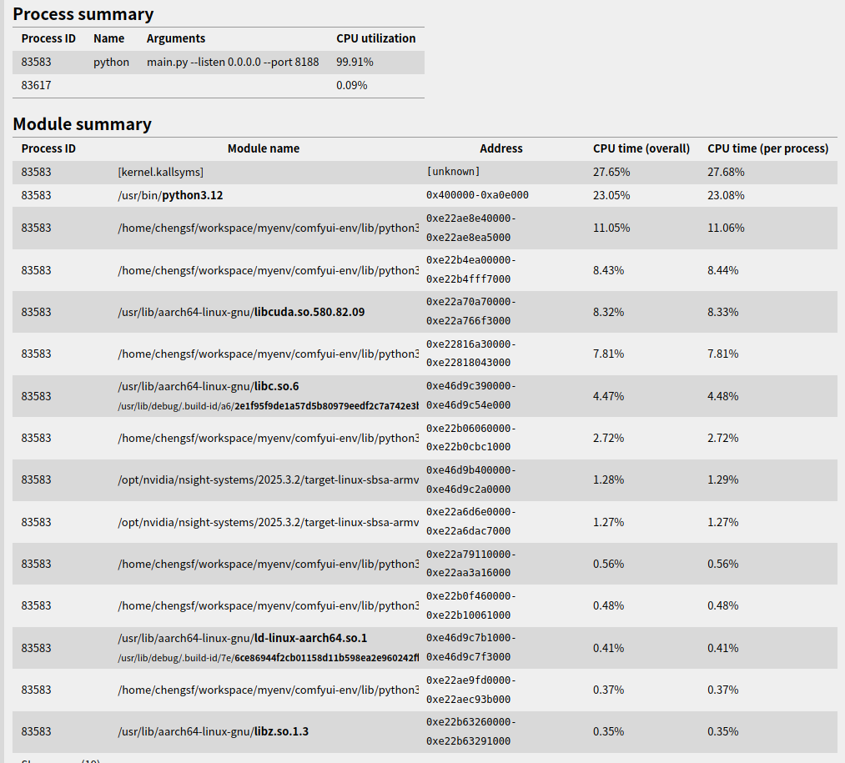
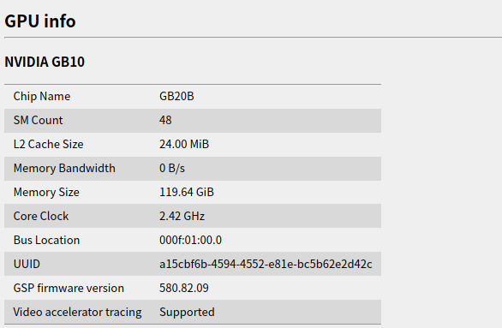

1.2.4 Nsys TimeLine View
各节点时延负载分析

时延
First image：
load_checkpoint: 484ms
encode_positive: 345ms
encode_negetive: 13.7ms
Sample: 2531ms
Decode: 533ms
Saveimage: 32.9ms

second：
load_checkpoint: NA
encode_positive: 14.47ms
encode_negetive: NA
Sample: 1684ms
Decode: 153ms
Saveimage: 29.5ms

CPU利用率
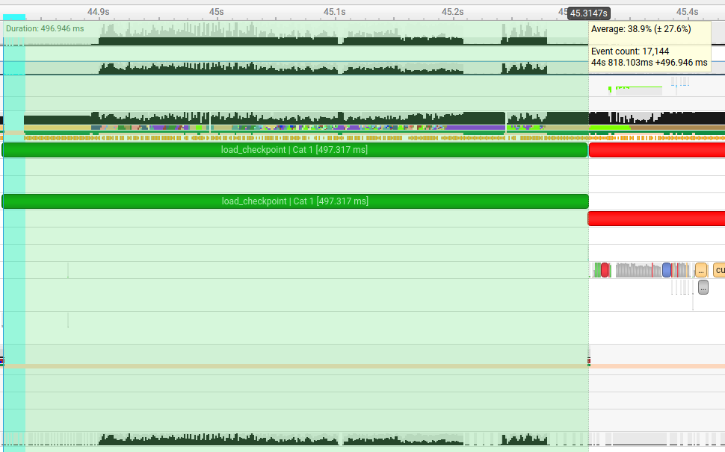
首张图：
load_checkpoint: 38.9% Average; 99% Peak
encode_positive: 5.9% Average，10% Peak；
encode_negetive: 5.9% Average，10% Peak；
Sample: 3.4% Average, 80% Peak
Decode: 5% Ave, 48% Peak
Saveimage: 5.9% Ave, 12% Peak

后续图：
encode_positive: 5.9% Average，10% Peak；
Sample: 3.4% Average, 80% Peak
Decode: 5% Ave, 48% Peak
Saveimage: 5.9% Ave, 12% Peak

MemoryUse
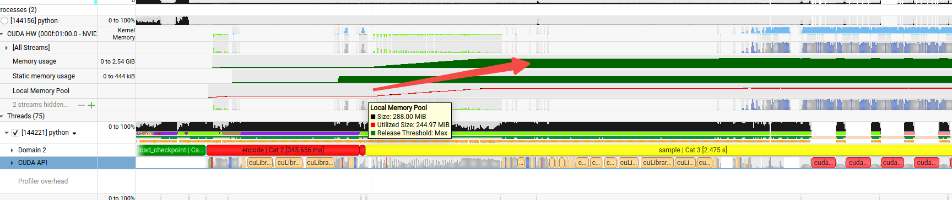
GPU：峰值2.54GB，主要是模型参数

带宽（峰值）
Memcpy H2D(Pageable)：55GB/s
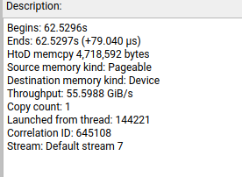
Memcpy D2D：245GB/s
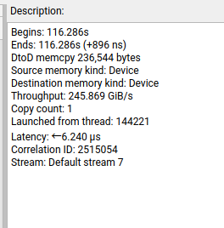
Memcpy D2H：14mb/s
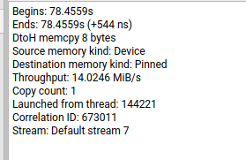
Memcpy D2H（Pageable）：46GB/s
